**VELAMMAL BODHI CAMPUS**

**(A CBSE – IIT/NEET Integrated Sr. Sec. School)**

**GRADE:** X **- Batch II GRAND TEST– 2 SUB:** SCIENCE (086)

**DATE:** 14.12.2023 **SCIENCE MARKS:**80(3 HOURS)

***General Instructions:***

*i. This question paper consists of 39 questions in 5 sections.*

*ii. All questions are compulsory. However, an internal choice is provided in some questions. A student is expected to attempt only one of these questions.*

*iii.* ***Section A*** *consists of 20 objective type questions carrying 1 mark each.*

*iv.* ***Section B*** *consists of 6 Very Short questions carrying 02 marks each. Answers to these questions should in the range of 30 to 50 words.*

*v.* ***Section C*** *consists of 7 Short Answer type questions carrying 03 marks each. Answers to these questions should in the range of 50 to 80 words*

*vi.* ***Section D*** *consists of 3 Long Answer type questions carrying 05 marks each. Answer to these questions should be in the range of 80 to 120 words.*

*vii.* ***Section E*** *consists of 3 source-based/case-based units of assessment of 04 marks each with sub-parts.*

**SECTION A**

1. An object is placed at a distance of 40cm in front of a concave mirror of a focal length of 20 cm. The image produced is:

a) virtual and inverted b)real and erect

c) real, inverted and of the opposite size as that of the object

d) real, inverted and of the same size as that of the object

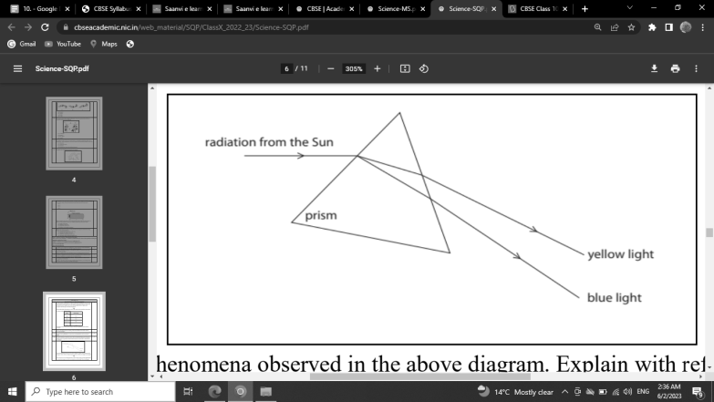2. Find out the phenomena observed in the diagram and find out which light has greater velocity.

1. Scattering; yellow light
2. Dispersion; blue light
3. Dispersion; yellow light
4. Total internal reflection; blue light

3. Compound X is a six carbon compound. When it is burnt, light is generated. Here, the colour of the flame is yellow because of the presence of carbon particles. Compound *X* cannot be

a) C6H12 b) C6H14 c) C6H6 d) C6H10

4. Which of the following statement about the given reaction is incorrect?

3Fe(s) + 4H2O(g) → Fe3O4 (s) + 4H2 (g)

(a) Iron metal is getting oxidized (b) Water is getting reduced

(c) Water is acting as a reducing agent (d) Water is acting as an oxidizing agent

5. In the double displacement reaction between aqueous potassium iodide and aqueous lead nitrate, a yellow precipitate of lead iodide is formed. While performing the activity, if lead nitrate is not available, which of the following can be used in place of lead nitrate?

(a) Lead sulphate (insoluble) (b) Lead acetate

(c) Ammonium nitrate (d) Potassium sulphate

**6.** Sodium carbonate is a basic salt because it is a salt of

(a) strong acid and strong base (b) strong acid and weak base

(c) weak acid and strong base (d) weak acid and weak base

7. Which of the following statements is correct about an aqueous solution of an acid and of a base?

(i) Higher the pH, stronger the acid (ii) Higher the pH, weaker the acid

(iii) Lower the pH, stronger the base (iv) Lower the pH, weaker the base

(a) (i) and (iii) (b) (ii) and (iii) (c) (i) and (iv) (d) (ii) and (iv)

8. Aluminium is used for making cooking utensils. Which of the following properties of Aluminium are not responsible for the same?

(i) Good thermal conductivity (ii) Good electrical conductivity

(iii) Ductility (iv) High melting point

(a) (i) and (ii) (b) (i) and (iii) (c) (ii) and (iii) (d) (i) and (iv)

9. Which of the following composition is used for dissolution of gold?

(a) Dilute HCl: Conc. HNO3 (3: 1) (b) Conc. HCl: Dilute HNO3 (3: 1)

(c) Conc. HCl: Conc.HNO3 (3: 1) (d) Dilute HCl: Dilute HNO3 (3: 1)

10. In plants the role of abscisic acid is:

a) Promote cell division b) Wilting of leaves

c) Promote the opening of stomatal pore d) Help in the growth of stem

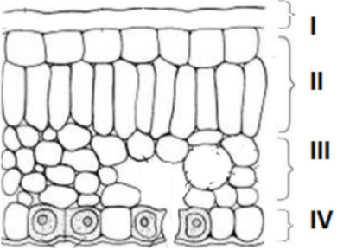11. In the given transverse section of the leaf, identify the layer of cells where maximum photosynthesis occurs.

a) I, II b) II, III c) III, IV d) I, IV

12. Which of the following is an example of genetic variation?

(a) One person has a scar but his friend doesn’t

(b) One person is older than the other

(c) Eats meat but her sister Geeta is a vegetarian

(d) Two children have different eye color

13. After our nose senses a smell, which option shows the mechanism of the travelling of sense in our body?

(a) Olfactory receptors → dendritic tip of a nerve cell → axon → nerve ending → release of signal dendritic tip of other nerve cell

(b) Olfactory receptors → dendritic tip of a nerve cell → axon → cell body → release of signal → dendritic tip of other nerve cell

(c) Gustatory receptors → dendritic tip of a nerve cell → cell body → axon → release of signal dendritic tip of other nerve cell

(d) Gustatory receptors → dendritic tip of a nerve cell → axon → cell body → release of signal dendritic tip of other nerve cell

14. Two plants one with round green seeds (RRyy) and another with wrinkled yellow (rrYY) seeds produce F1 progeny that have round yellow (RrYy) seeds. When F1 plants are self-pollinated, the F2 progeny will have a new combination of characters. Choose the new combinations from the following:

(i) Round, yellow (ii) Round, green

(iii) Wrinkled, Yellow (iv) Wrinkled, green

(a) (i) and (ii) (b) (i) and (iv) (c) (ii) and (iii) (d) (i) and (iii)

15. The growth of tendril in pea plants is due to

a) Effect of light b) Effect of gravity

c) Rapid cell divisions in tendrillar cells that are away from the support

d) Rapid cell divisions in tendrillar cells in contact with the support

16. A sportsman, after a long break of his routine exercise, suffered muscular cramps during a heavy exercise session. This happened due to:

a) Lack of carbon dioxide and formation of pyruvate.

b) Presence of oxygen and formation of ethanol.

c) Lack of oxygen and formation of lactic acid.

d) Lack of oxygen and formation of carbon dioxide.

17. Which of the following features relates to biodegradable substances?

a) Broken down by biological processes b) Remain inert

c) Persist in environment for long time d) May harm the ecosystem

**Question no 18 to 20 is based on Assertion (A) and Reason (R). Answer these questions selecting the appropriate option given below:**

a) Both assertion (A) and reason (R) are true and reason (R) is the correct explanation of assertion (A)

b) Both assertion (A) and reason (R) are true but reason (R) is not the correct explanation of assertion (A)

c) Assertion (A) is true but reason (R) is false

d) Assertion (A) is false but reason (R) is true

18. Assertion (A): Silver bromide is used in photography.

Reason (R): Silver bromide is photosensitive. It decomposes and is converted into metallic silver grains when light is incident on it

19. Assertion (A): The danger signals installed at the top of tall buildings are red in color

Reason (R): Because the wavelength of the red is less compared to the violet light

20. Assertion: Ozone is both beneficial and damaging.

Reason: Stop the release of chlorofluorocarbons to protect the ozone.

**SECTION B**

21. a. A girl needs a lens of power -4 D for the right eye and -2 for the left eye. What is the focal length of the corrective lens?

(OR)

b. As Violet color is scattered more than blue color, why sky appear as blue color to us rather than violet color. Explain

22. How would the reading of voltmeter (V) change, if it is connected between B and C? Justify your answer.

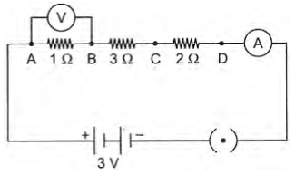

23. A plant X was enclosed in a glass jar with some lizards. A similar plant Y was enclosed in another glass jar but without lizards. Both the jars are kept under the same light conditions for a few hours. Which plant is likely to photosynthesize more and why?

OR

Proteinuria is a condition in which significant amounts of protein can be detected in urine. Which process in the nephron is likely to be affected causing proteinuria? Justify.

24. What happens when zinc granules are treated with a dilute solution of

(i) Hydrochloric acid (ii) Sodium hydroxide, also write the chemical equations.

25. What could be the two most likely reasons for unicellular organisms to reproduce only through asexual reproduction?

26. Shown below are two food pyramids. The pyramid representing the land ecosystem is traditional with producers being greater in mass than primary consumers and so on. Sometimes, in aquatic ecosystems, an inverted pyramid exists. Here, the total mass of producers (phytoplankton) is much smaller than the top consumers (big fishes).

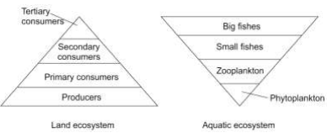

(a) Which level is likely to have the most amount of energy in such an aquatic ecosystem? Give a reason to support your answer.

(b) Such aquatic ecosystems are not considered to be sustainable. Justify this statement.

**SECTION C**

27. a. A 3cm tall object is placed perpendicular to the principal axis of a convex mirror with a focal length of 15 cm. The distance of the object from the lens is 20 cm. Find the position, nature, and size of the image.

OR

b.i) List the parts of the human eye that control the amount of light entering into it.

ii) Draw the ray diagram for hyper-metropic condition

iii) A person cannot see the objects distinctly, when placed at a distance less than 50 cm. Calculate the power and nature of the lens heshould be using to see clearly the object placed at a distance of 25 cm from his eyes.

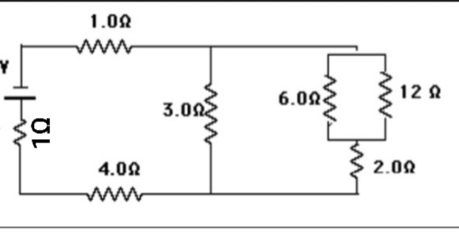28. Calculate the effective resistance for the following circuit.

29. i) AB is a current carrying conductor in the plane of the paper as shown in the figure. What are the directions of magnetic fields produced by it at points P and Q?

ii) If the r1 =2r2, calculate the ratio of the strengths of the magnetic field of P to Q?

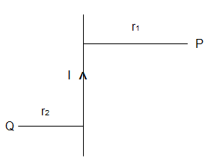

30. A magnesium ribbon is burnt in oxygen to give a white compound X accompanied by emission of light. If the burning ribbon is now placed in an atmosphere of nitrogen, it continues to burn and forms a compound Y.

(a) Write the chemical formulae of X and Y.

(b) Write a balanced chemical equation, when X is dissolved in water.

(c) Why should a magnesium ribbon be cleaned before burning in air?

31. Explain the following

(a) Reactivity of Aluminium decreases when it is dipped in HNO3

(b) NaCl does conduct electricity in aqueous solution as well as in molten state.

(c) Iron articles are galvanized.

(OR)

Compound X and Aluminium are used to join railway tracks.

(a) Identify the compound X

(b) Name the reaction and why is it called so?

(c) Write down its reaction.

32. Name the parts (A) to (E) in the following diagram.

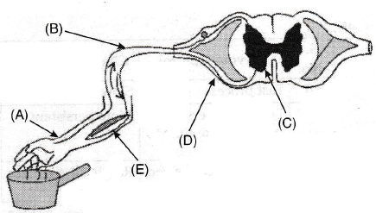

What is the term given to the sequence of events occurring in the diagram?

33. What is the probability of a girl or a boy being born in a family? Justify your answer

**SECTION D**

34. (i) Consider a conductor of resistance ‘R’, length ‘L’, thickness ‘d’ and resistivity ‘ρ’. Now this conductor is cut into five equal parts. What will be the new resistivity of each of these parts? Why?

(ii) Find the resistance if all of these parts are connected in: (a) Parallel (b) Series

(iii) An electric bulb is rated at 200 V–100 W.

a) What is its resistance?

b) Five such bulbs burn for 4 hours. What is the electrical energy consumed? Calculate the cost, if the rate is 50 paise per unit.

OR

i) Draw a schematic labeled diagram for domestic house hold circuit.

ii) Why it is necessary to provide____

a) Fuse in a electrical circuits

b) Earth wire to electrical appliances or metallic bodies.

iii) Why we prefer DC over AC to store in our Batteries. Can we store AC? Discuss.

35. (a) What are hydrocarbons? Give examples.

(b) Give the structural differences between saturated and unsaturated hydrocarbons. (c) Draw the electron dot structure of ethyne and also draw its structural formula.

(d) Compare the ability of catenation of the two elements, carbon and silicon.

(e) What is the role of nickel metal in the hydrogenation of alkene. Give reaction.

OR

Compound ‘A’ having molecular formula, C2H4O2 reacts with sodium metal to form a compound ‘B’ and evolves a gas ‘C’ which burns with a pop sound. Compound ‘A’ on treatment with an alcohol ‘D’ in presence of an acid forms a sweet-smelling compound ‘E’ having molecular formula, C4H8O2. On addition of NaOH to ‘A’, it also gives ‘B’ and water. ‘E’ on treatment with NaOH solution gives ‘B’ and ‘D’. Identify A, B, C, D and E and write down the reactions involved.

36. (a) Certain specialised cells in animals called stem cells have the ability to divide and differentiate into different cell types. This helps in the replacement of a damaged organ.

Name and explain two methods of asexual reproduction that are similar to stem cells and occur mostly in multicellular organisms.

(b) Identify TWO pairs of reproductive organs in males and females that are functionally similar to each other. Justify.

Or

(a) Sagar saw a beautiful rose and smelled it. As he smelled it, he happened to touch a thorn and pull his hand away. State TWO differences and similarities each in the way the nervous system performs the two actions.

(b) Are all involuntary actions reflex actions? Justify.

**SECTION E**

37. We can see when the pencil immersed in water it appears like bent at the water air interface. Also, the letters appears to be raised when we will see that letters through a glass slab placed over it. If the media used are different that means the bending of light is different in different media. And hence we can say that the light does not travel along a straight line path through different media. According to the velocity of light in that medium the bending of light takes place. Thus, we can say the phenomenon in which light ray bends or changes its direction when traveling from one medium to other is called as refraction of light.

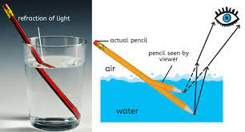

i) If the refractive indices of glass and ice are 1.52 and 1.31 respectively. Then in which medium the velocity of light is more? What it’s value? (Velocity of light in air = 3x108 m/s)

ii) If the Refractive index of diamond is found to be highest i.e. 2.42 then what it indicates?

iii) How atmospheric refraction causes the twinkling of stars?

OR

What will you observe if we took a glass filled with kerosene (1.44) instead of water (1.33)? Compare the angle of refraction in both cases.

38. A pH meter is a scientific instrument that measures the hydrogen-ion activity in water based solution water-based solutions, indicating its acidity or alkalinity. expressed as pH. The pH meter measures the difference in electrical potential between a pH electrode and a reference electrode, and so the pH meter is sometimes referred to as a "potentiometric pH meter". The difference in electrical potential relates to the acidity or pH of the solution. The pH meter is used in many applications ranging from laboratory experimentation to quality control. Plants need a specific pH range for proper growth. The soil may be acidic, basic or neutral depending upon the relative concentration of H+ and ${OH}^{-}$. The pH of any soil can be determined by using pH paper. If the soil is too acidic, it can be corrected by adding lime to it. If the soil is too basic, it can be corrected by adding organic manure which contains acidic materials.

1. Which of the following statement is not correct regarding pH Scale?

(a) It is the negative logarithm of H+ ion concentration of a given solution.

(b) It is the positive logarithm of H+ ion concentration of a given solution.

(c) It is a 0 – 14 point scale. (d) pH is an example of an extrinsic property.

2. What is the pH of distilled water?

(a) 0 (b) 1 (c) 7 (d) 14

3. The pH of soil X is 7.5 while that of soil Y is 4.5. Which of the two soils, should be treated with powdered chalk to adjust its pH and why?

4. Why we measure the pH of sea water? Name the other fields where pH scale is important for measurements?

39. A scientist crossed pure-bred tall (dominant) pea plant with pure-bred dwarf (recessive) pea plant he will get pea plants in F1 generation. If now he self-crossed the pea plant of F2 generation again he obtained pea plants in F2 generation.

Answer the following questions:

(a) What will be the set of genes present in the F1 generation?

(b) State the genotypic ratio of TT to tt in F2 generation.

(c)What do the plants of F1 generation look like?

(d) How many dwarf plants will be produced when a total 160 plants are produced in F2 generation?

***\*\*\* ALL THE BEST \*\*\****